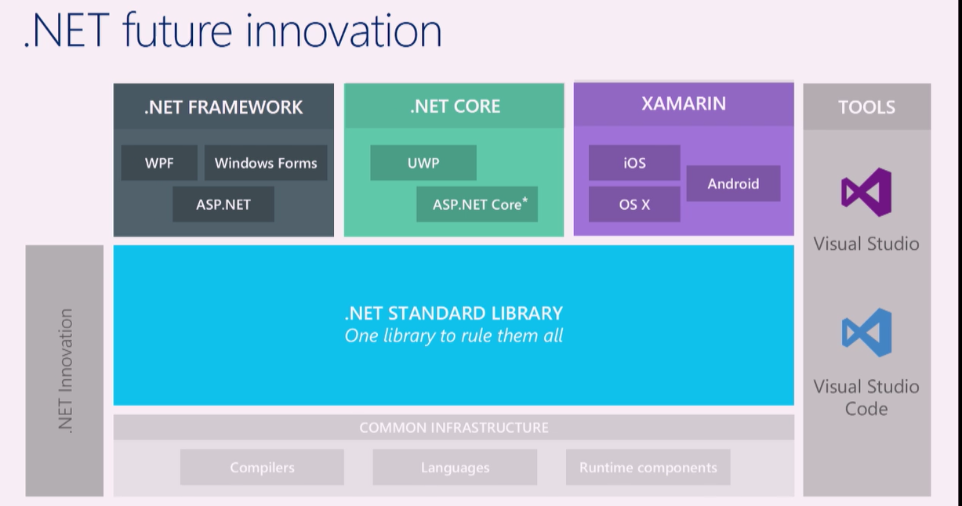

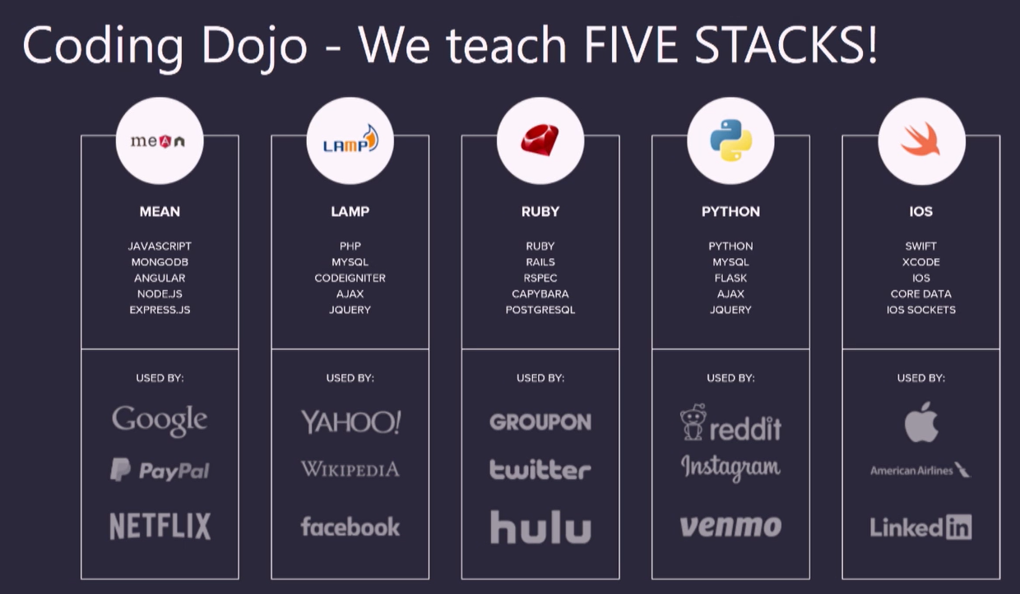

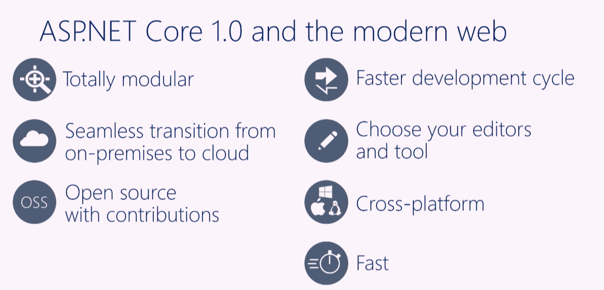

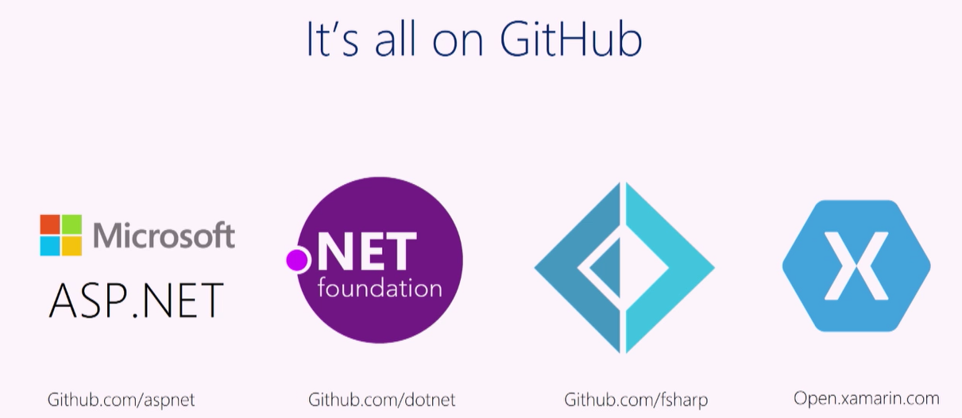

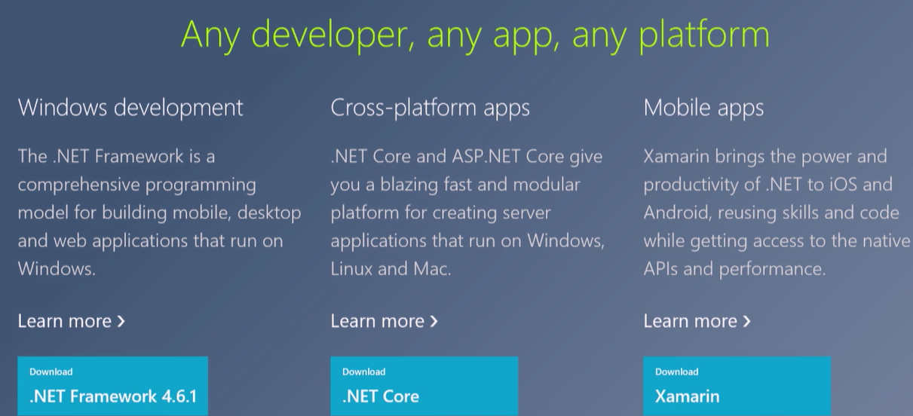

An ASP.NET Core app is simply a console app that creates a web server in its Main method

<https://docs.asp.net/en/latest/getting-started.html>

此处不同：

app.Run(context =>

{

UTF8Encoding uniencoding = new UTF8Encoding();

byte[] result = uniencoding.GetBytes("Hello from ASP.NET Core!");

context.Response.ContentType = "text/html";

return context.Response.Body.WriteAsync(result, 0, result.Length);

});

<https://github.com/kriasoft/aspnet-starter-kit>

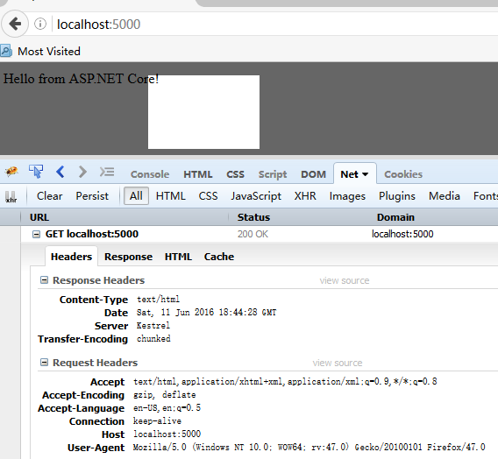

**A service is a component that is intended for common consumption in an application. Services are made available through dependency injection.**

**<https://docs.asp.net/en/latest/conceptual-overview/choosing-the-right-dotnet.html>**

https://visualstudio.github.com/